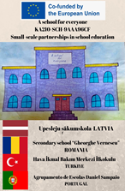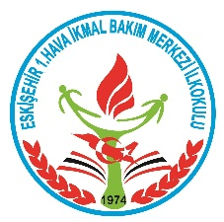
Erasmus + project “A school for everyone”

Writing Poems and Drawing Pictures On The Subject Using The Acrostic Method

SECTION A – IDENTIFICATION
Name of the organization/Institution  implementing practice |  | 1.Hava İkmal Bakım Merkezi Primary School
Place of implementation |  | Suitable for both mainstream and inclusive classrooms.
SECTION B – DESCRIPTION
Target group / Beneficiaries |  | Students aged 9–10 (Grades 4 ), including students with diverse learning needs and language backgrounds.
The main objectives |  | To develop students’ reading comprehension and written expression  To encourage personal interpretation and emotional connection to literary texts  To foster inclusive participation through structured thinking  To revealstudents creativityand perspectivecs.  To express the feelings and thoughts of Afgan and low academic level students through poetry.
Experts/staff |  | Clasroom teacher
The description of the practice (Up to 10 sentences) |  | In this lesson, by readingthe poem”My Teacher”:  - What kind of teacher do you want to be?  - What department should l study to become a teacher?  - Can you write an acrostic with the theme of „Teacher” as a group  - Can you draw a picture that describes the teacher?  Our students produce ideas by collaborating within the given time.  Thus,they express their feelings and thoughts about the teaching profession through acrostics and pictures.  Activities are carried out with Afghan children of different cultures and integration students using the inclusive education method.
Methodology/Didactic tools |  | Inclusive teaching strategy:  Peer collaboration and group reflection  Acrostic  İnduction
Additional materials /Equipment needed |  | Textbook  Paper,pencils and paints  Smart board
SECTION C – CONCLUCION
Conclusion/ | It is an inclusive method that enables cooperation and strengthens participation through grop work and the acrostic method.
Recommendation and guidelines | Demonstrate the method first with a sample character  Allow flexible formats (written, verbal, visual)  Use supportive materials (e.g., simplified text) when needed  Encourage group sharing and peer learning

