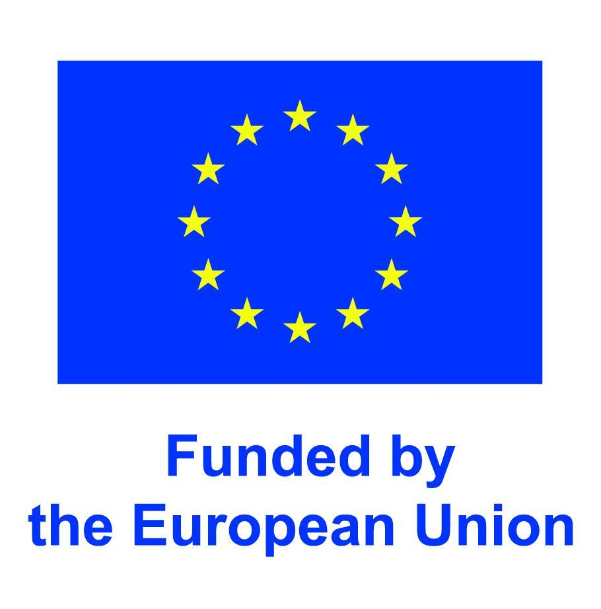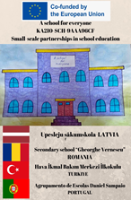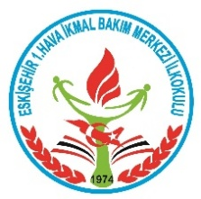

Erasmus +Project “A School For Everyone”

Let's Get to Know Countries in the World

SECTION A – IDENTIFICATION
Name of the organization/Institution  implementing practice |  | 1.Hava İkmal Bakım Merkezi Primary School
Place of implementation |  | Suitable for both mainstream and inclusive classrooms.
SECTION B – DESCRIPTION
Target group / Beneficiaries |  | Students aged 7–10 (Grades 1–4), including students with diverse learning needs and language backgrounds.
The main objectives |  | - Students can show basic countries on a world map.  - They develop map reading skills.  - They learn to solve problems by collaborating.  - They use technology effectively for learning purposes.  - Students with different learning styles are included in the learning process.
Experts/staff |  | Classroom Teacher
The description of the practice (Up to 10 sentences) |  | Step 1: Introduction (5 minutes)  - The teacher projects a world map image to the class.  - Asks intriguing questions like, “Do you know how many countries there are in the world?”  - Short conversation with students: “Have you ever been to another country?”  - Do you have friends from another country?  Step 2: Puzzle Actıvıty (15 minutes)  - Students are divided into mixed groups (with support materials for students with visual, hearing or learning disabilities).  - Each group is given a divided world map puzzle (colorful, large pieces, easy to put together and remove).  - Students try to find the location of the countries by putting the pieces together.  The names of the countries are written on the back of the puzzle, and students read the country name as they place the pieces in their place.  Step 3: Vısual Support (10 minutes)  The teacher shows some selected countries on the screen by enlarging them (example: Turkey, Brazil, Japan, Canada).  The country's flag, symbols or cultural elements are also introduced.  The flags of various countries are painted.  - Students from different countries in the class (Syrian, Afghan...) are told about their own countries and cultures.
Methodology/Didactic tools |  | Step 4: Digital Game Activity (10 minutes)  Games Available:  World Geography Games Online - Let's play and learn Geography!
Additional materials /Equipment needed |  | - Students from different countries will be physically involved in the lesson by explaining their countries.  - Large print materials for students with learning disabilities  - Icon-enhanced country cards for those who need language support  - Auditory and visual learning supported by maps and puzzles
SECTION C – CONCLUCION
Conclusion/ | - Each group shares their puzzle work in class.  - The group that completes the puzzle first is applauded.  - The painted flags are placed in those countries.  - Students from different social groups (those from different countries, those with hearing and vision problems, students with low academic achievement...) introduce their work in the relevant sections of the lesson steps.
Recommendation and guidelines | - Provide a calm and sensory-friendly environment for students with sensitivities.  - Use visual cues and modeling to support students’ understanding of steps.  - Students are asked if they know the countries and their locations on the map.  - Students form groups.  - Puzzles and country flags to be colored are distributed to students.  - The group that completes the first puzzle is applauded after a time limit.  - A coloring activity is carried out for students who are visual.  - A digital game showing the locations of countries is played on the smart board.

